**Submitted by – Sanket Bollamwar**

**Basic Data Structures in Java.:**

Q1: Find out if the given number is an Armstrong number or not.

**Description: -**

An Armstrong number of three digits is an integer, where the sum of the cubes of its digits is equal to the number itself.

Consider the example: 371=> 3^3 + 7^3 + 1^3 = 371 (If you add those all numbers, the final digit should be same as given number).

**Specifications:**

class ArmstrongOrNot {

public boolean armstrongCheck(int num) {}

public class Assignment1Q1 {

public static void main(String[] args) {}

}

**Code:**

import java.beans.Transient;

import java.util.Scanner;

class ArmstrongOrNot {

    static boolean armstrongCheck(int num) {

        int n= num, x=0, y;

        while (n != 0) {

            y = n % 10;

            x+= y * y * y;

            n = n/10;

        }

        if (x == num)

         return true;

        else return false;

    }

}

public class Assignment1Q1   {

     public static void main(String[] args) {

        ArmstrongOrNot newArmstrongOrNot= new ArmstrongOrNot();

        int num;

        System.out.println("Enter the number: ");

        Scanner in = new Scanner(System.in);

        num = in.nextInt();

        if (newArmstrongOrNot.armstrongCheck(num))

            System.out.println("Armstrong number ");

        else

            System.out.println("Not Armstrong number ");

    }

}

**Output:**

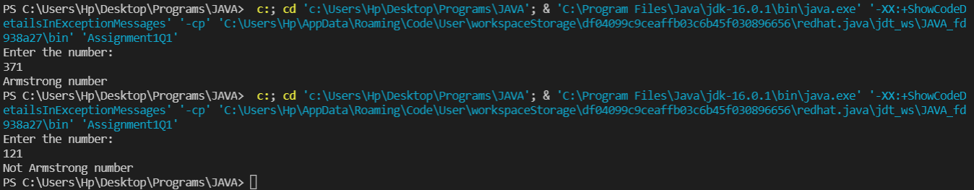

Q2. Find out all the Armstrong numbers falling in the range of 100-999

Description: -

An Armstrong number of three digits is an integer, where the sum of the cubes of its digits is equal to the number itself.

Consider the example: 371=> 3^3 + 7^3 + 1^3 = 371 (If you add those all numbers, the final digit should be same as given number).

Find the Armstrong numbers between 100 to 999.

**Test cases:**

Output: 153 370 371 407

**Specifications:**

class ArmstrongNumBetweenRange{

public int [] armstrongNumbersInRange(int min , int max){}

}

public class Assignment1Q2 {

public static void main (String [] args) {

int min = 100; int max = 999;

}

}

**Code:**

class ArmstrongNumBetweenRange {

    static void armstrongNumBetweenRange(int min, int max) {

        int mini=min;

        int maxi=max;

        for (int i = min; i <= max; i++)

        {

            int n= i, x=0, y;

            while (n != 0)

            {

                y = n % 10;

                x+= y * y * y;

                n = n/10;

            }

            if( x ==i )

            {

                System.out.print(i + " ");

            }

        }

    }

}

public class Assignment1Q2{

    public static void main(String[] args) {

        int min=100, max=999;

        ArmstrongNumBetweenRange newArmstrongNumBetweenRange= new ArmstrongNumBetweenRange();

        ArmstrongNumBetweenRange.armstrongNumBetweenRange(min, max);

    }

}

**Output:**

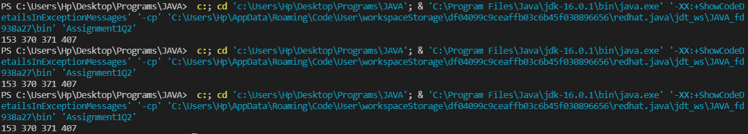

Q3. Find out the simple as well as the compound interest of supplied value

Description: -

Simple Interest: - Generally, simple interest paid or received over a certain period is a fixed percentage of the principal amount that was borrowed or lent

Simple Interest = (P×r×n)/100

where:

P = Principal amount

r = Annual interest rate

n = Term of loan, in years

Compound Interest: -Compound interest accrues and is added to the accumulated interest of previous periods; it includes interest on interest, in other words.

Compound Interest = P(1+r) ^t-P

Where:

P=Principal amount

r=Annual interest rate

t=Number of years interest is applied

**Specifications:**

class SiCi {

public double simpleInterest(double principalAmount,int time,double interestRate){}

public double compoundInterest(double principalAmount,int time,double interestRate){}

}

public class Assignment1Q3 {

public static void main (String args[]) {}

}

**Code:**

import java.util.Scanner;

class SiCi {

    public static double simpleInterest(double principalAmount,int time,double interestRate){

        double SI= ((principalAmount*time*interestRate)/100);

        return SI;

    }

    public static double compoundInterest(double principalAmount,int time,double interestRate){

        double CI= (principalAmount*(Math.pow((1+interestRate/100), time)));

        return CI;

    }

}

public class Assignment1Q3 {

    public static void main(String[] args) {

        try(Scanner sc = new Scanner(System.in)){

        System.out.println("Enter principle amount: ");

        double principalAmount = sc.nextDouble();

        System.out.println("Enter time: ");

        int time = sc.nextInt();

        System.out.println("Enter intrest rate: ");

        double interestRate = sc.nextDouble();

        System.out.println("Simple Intrest: "+SiCi.simpleInterest(principalAmount, time, interestRate));

        System.out.println("Simple Intrest: "+SiCi.compoundInterest(principalAmount, time, interestRate));

        }

    }

}

**Output:**

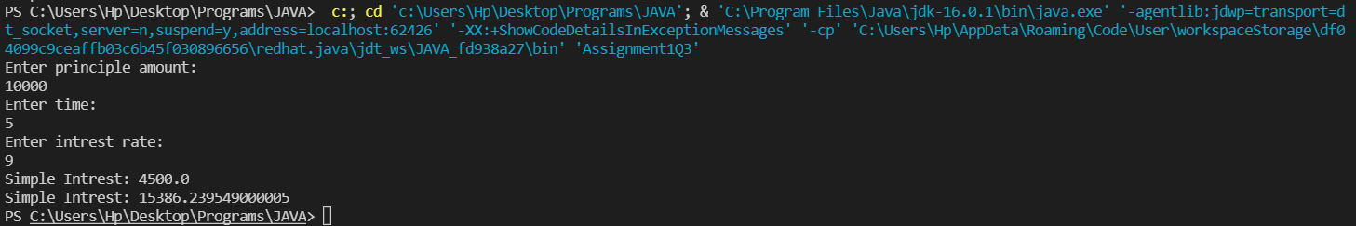

Q4. Supply marks of three subject and declare the result, result declaration is based on below conditions:

Condition 1: -All subjects marks is greater than 60 is Passed

Condition 2: -Any two subjects marks are greater than 60 is Promoted

Condition 3: -Any one subject mark is greater than 60 or all subjects’ marks less than 60 is failed.

**Description: -**

Specify the marks of 3 subjects and the results will be declared based on the conditions above and for reference go through the test cases for better understanding.

**Test cases: -**

TestCase1: -

Input: - 10 10 10

Output: - failed

TestCase2: -

Input: - 70 10 10

Output: - failed

TestCase3: -

Input: - 70 80 60

Output: - passed

TestCase4: -

Input: - 70 60 40

Output: - promoted

**Specifications:**

class ResultDeclaration{

public String declareResults( double subject1Marks, double subject2Marks, double subject3Marks) {}

}

public class Assignment1Q4 {

public static void main(String[] args) {}

}

**Code:**

import java.util.Scanner;

class ResultDeclaration{

    public static String declareResults( double subject1Marks, double subject2Marks, double subject3Marks) {

        double S1M=subject1Marks;

        double S2M=subject2Marks;

        double S3M=subject3Marks;

        if(S1M>=60.0 && S2M>=60.0 && S3M>=60.0)

        return "Passed";

        else if ((S1M>=60.0 && S2M>=60.0 && S3M<=60 )||(S1M>=60.0 && S2M<=60.0 && S3M>=60.0)||(S1M<=60.0 && S2M>=60.0 && S3M>=60.0))

        return "Promoted";

        else

        return "Failed";

    }

}

public class Assignment1Q4 {

    public static void main(String[] args) {

        try(Scanner sc= new Scanner(System.in)){

        System.out.println("Enter Marks in subject 1: ");

        double subject1Marks =sc.nextDouble();

        System.out.println("Enter Marks in subject 2: ");

        double subject2Marks =sc.nextDouble();

        System.out.println("Enter Marks in subject 3: ");

        double subject3Marks =sc.nextDouble();

        System.out.println( ResultDeclaration.declareResults(subject1Marks, subject2Marks, subject3Marks));

        }

    }

}

**Output:**

**Test Case 1:**

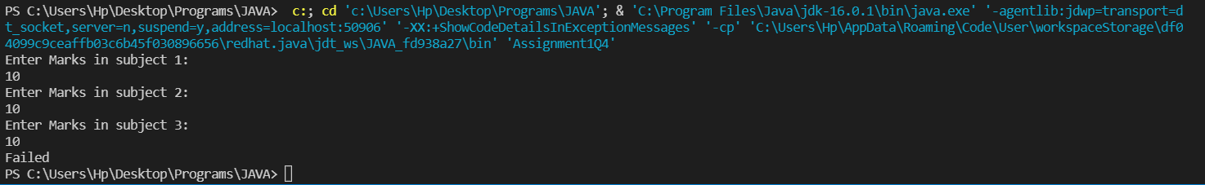

**Test Case 2:**

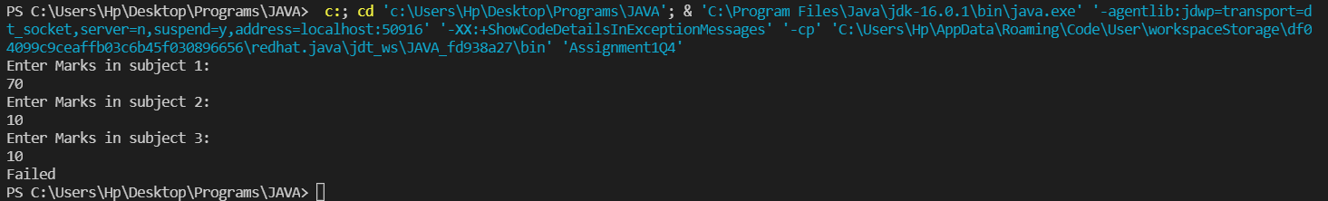

**Test Case 3:**

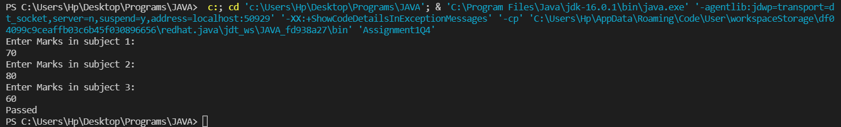

**Test Case 4:**

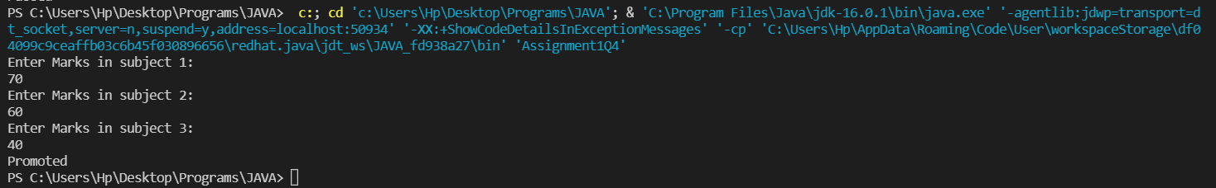

Q5. Calculate the income tax on the basis of following table.

Note: -Assume slab is consider for Male, Female as well as Senior citizen

Slab Income Range Tax payable in Percentage

Slab A 0-1,80,000 Nil

Slab B 1,81,001-3,00,000 10%

Slab C 3,00,001-5,00,000 20%

Slab D 5,00,001-10,00,000 30%

Accept CTC from user and display tax amount

Description: -

Given 4 different types of slabs along with the percentage of tax payable in association with income ranges which are applicalble to Male,Female as well as Senior citizen.You need to specify the CTC to display the taxable amount using the above slab rates.

Specifications:

class TaxAmount{

public double calculateTaxAmount(int ctc){}

}

public class Assignment1Q5 {

public static void main(String args[]) {}

}

**Code:**

import java.util.Scanner;

class TaxAmount{

    public static double calculateTaxAmount(int ctc){

        double amount;

        if (ctc <= 180000) {

            amount = 0.00;

        } else if (ctc > 180000 && ctc <= 300000) {

            amount = (ctc*10)/100 ;

        } else if (ctc > 300000 && ctc <= 500000) {

            amount = (ctc*20)/100;

        } else {

            amount = (ctc*30)/100;

        }

        return amount;

    }

}

public class Assignment1Q5 {

    public static void main(String[] args) {

        try (Scanner sc = new Scanner(System.in)) {

            System.out.println("Enter income: ");

            int income = sc.nextInt();

            System.out.println("Taxable amount"+(TaxAmount.calculateTaxAmount(income)));

        }

    }

}

**Output:**

**Test Case 1 & 2:**

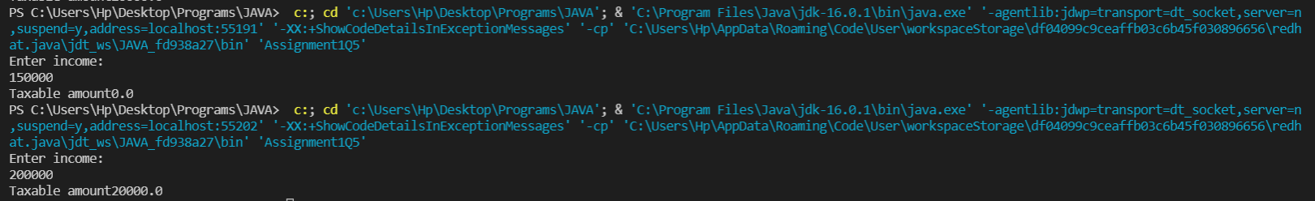

**Test Case 3 & 4:**

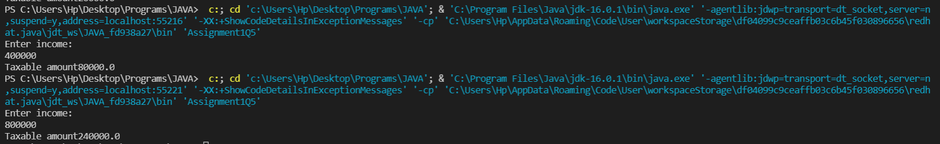

Q6. Consider a CUI based application, where you are asking a user to enter his Login name and password, after entering the valid user-id and password it will print the message “Welcome” along with user name. As per the validation is concerned, the program should keep a track of login attempts. After three attempts a message should be flashed saying “Contact Admin” and the program should terminate.

**Code:**

import java.util.Scanner;

class Login{

    static String userId = "Ajay";

    static String password = "password";

    public static boolean loginUser(String user, String pass) {

        if (userId.equals(user) && password.equals(pass))

        return true;

        else

        return false;

    }

}

public class Assignment1Q6 {

    public static void main(String[] args) {

        try (Scanner sc = new Scanner(System.in)) {

            String user, pass;

            int attempt = 0;

            do {

                System.out.println("Enter UserID: ");

                user = sc.next();

                System.out.println("Enter Password: ");

                pass = sc.next();

                boolean ans= Login.loginUser(user,pass);

                if (ans == true) {

                    System.out.println("Welcome Ajay");

                    break;

                }

                else if (ans == false && attempt < 3) {

                    System.out.println("You have entered wrong credentials ,please enter the right credentials.\n");

                    attempt += 1;

                }

            } while (attempt != 3);

            if (attempt >= 3) {

                System.out.println("\nYou have entered wrong credentials 3 times\n");

            }

        }

    }

}

**Output:**

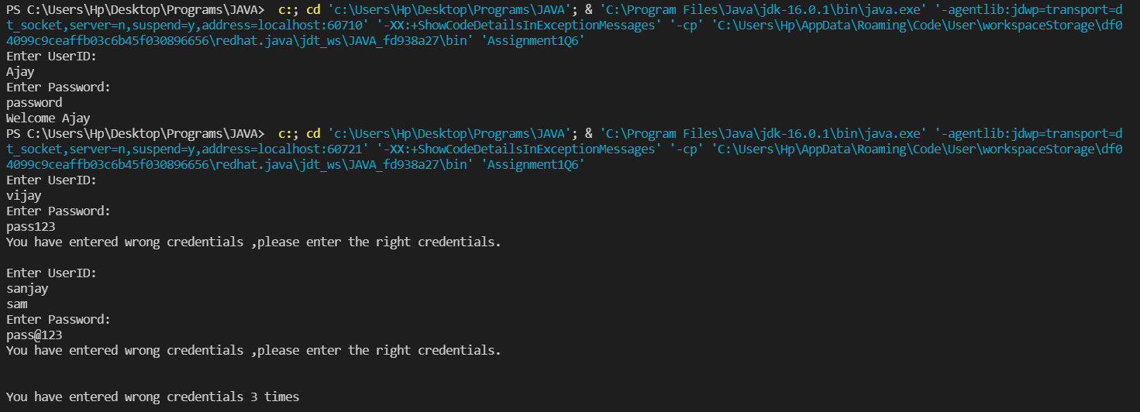

Q7. There is an Array which is of the size 15, which may or may not be sorted. You should write a program to accept a number and search if it in contained in the array

Example:

5 12 14 6 78 19 1 23 26 35 37 7 52 86 47

Value to be search is 19

Description: -

Given an array, the task is to check whether a certain element is present in this given Array or not.

Specifications-

class SearchArray{

public boolean searchArray(int[] arr,int toCheckValue){}

}

public class Assignment1Q7 {

public static void main(String[] args) {

int arr[] = { 5,12,14,6,78,19,1,23,26,35,37,7,52,86,47};

int valueToCheck = 19;

}

**Code:**

class SearchArray{

    public static boolean searchArray(int[] arr,int toCheckValue){

        for(int i=0; i<arr.length; i++)

        {

            if(arr[i]==toCheckValue)

            {

                return true;

            }

        }

        return false;

    }

}

public class Assignment1Q7 {

    public static void main(String[] args) {

        int arr[] = { 5,12,14,6,78,19,1,23,26,35,37,7,52,86,47};

        int valueToCheck = 19;

        boolean ans = SearchArray.searchArray(arr,valueToCheck );

        if(ans==true){

            System.out.println("Found Number !!");

        }

        else{

            System.out.println("Didn't found the number !!");

        }

    }

}

**Output:**

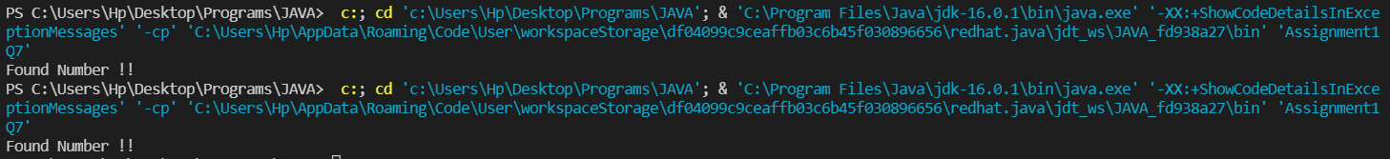

Q8. Using the below table write method apply sorting using Bubble Sort.

Example:

5 12 14 6 78 19 1 23 26 35 37 7 52 86 47

Description: -

Bubble sort is a simple sorting algorithm. This sorting algorithm is comparison-based algorithm in which each pair of adjacent elements is compared and the elements are swapped if they are not in order. This algorithm is not suitable for large data sets as its average and worst case complexity are of Ο(n2) where n is the number of items.

Example-

Input: 5 12 14 6 78 19 1 23 26 35 37 7 52 86 47

Output: 1 5 6 7 12 14 19 23 26 35 37 47 52 78 86

Specifications:

class BubbleSort{

public int[] bubbleSort(int arr[]) {}

}

public class Assignment1Q8 {

public static void main(String args[]) {

int arr[] = {5,12,14,6,78,19,1,23,26,35,37,7,52,86,47};

}

}

**Code:**

class BubbleSort{

    public static int[] bubbleSort(int arr[]) {

        for (int i = 0; i < arr.length; i++) {

            for (int j = i + 1; j < arr.length; j++) {

                if (arr[i] > arr[j]) {

                    int temp = arr[i];

                    arr[i] = arr[j];

                    arr[j] = temp;

                }

            }

        }

        return arr;

    }

}

public class Assignment1Q8 {

    public static void main(String args[]) {

        int arr[] = {5,12,14,6,78,19,1,23,26,35,37,7,52,86,47};

        System.out.println("Array before sorting :");

        for(int i=0;i<arr.length;i++){

            System.out.print(arr[i]+" ");

        }

        int newarr[]= BubbleSort.bubbleSort(arr);

        System.out.println("\n\nArray after sorting :");

        for(int i=0;i<newarr.length;i++){

            System.out.print(arr[i]+" ");

        }

    }

}

**Output:**

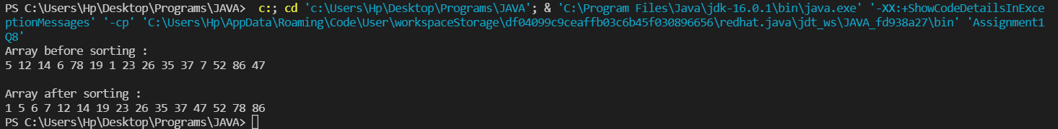

**Q9. Accept the marks of three students for the subject say A, B, C. Find the total scored and the average in all the subjects. Also Find the Total and Average scored by students in each respective Subject.**

**Description: -**

Enter the marks of 3 students for subjects A,B,C. Find the total marks secured by respective student in all the subjects and also find the total and average scored by students subject wise.

**Example: -**

Sample Input: -

                             marks of Student 1 in subjects A,B,C

                                           10 20 30

                             marks of Student 2 in subjects A,B,C

                                           10 20 30

                             marks of Student 3 in subjects A,B,C

                                           10 20 30

Sample Output: -

180                                    //Total marks of all the students in all subjects

60.0                                   //Average marks of all the students in all subjects

30                                       // Total marks scored by students in subject A

10.0                                   // Average marks scored by students in subject A

60                                       // Total marks scored by students in subject B

20.0                                   // Average marks scored by students in subject B

90                                       // Total marks scored by students in subject C

30.0                                   // Average marks scored by students in subject C

**Specifications:**

class Student {  
    private int subjectA,subjectB,subjectC;  
  
    public int studentsTotalMarksInAllSubjects(Student[] students) {}  
  
    public double studentsAverageMarksInAllSubjects(Student[] students) {}  
    public int[] subjectWiseMarks(Student[] students,String subjectName)  
    public int subjectATotalByStudents(int[] marks) {}  
    public int subjectBTotalByStudents(int[] marks) {}  
    public int subjectCTotalByStudents(int[] marks) {}

   public int subjectTotalByStudents(int[] marks)

    public double subjectAAverageByStudents(int[] marks) {}  
    public double subjectBAverageByStudents(int[] marks) {}  
    public double subjectCAverageByStudents(int[] marks) {}  
  
}  
  
public class Assignment1Q9 {  
  
    public static void main(String[] args) {}  
}

**Code:**

import java.util.Scanner;

class Student {

    static int subjectA, subjectB, subjectC;

    static int studentsTotalMarksInAllSubjects(int[] marks) {

        int sum = 0;

        for (int i = 0; i < 9; i++) {

            sum += marks[i];

        }

        return sum;

    }

    static double studentsAverageMarksInAllSubjects(int[] marks) {

        int sum = studentsTotalMarksInAllSubjects(marks);

        int avg = sum / 3;

        return avg;

    }

    static int subjectATotalByStudents(int[] marks) {

        int sum = 0;

        for (int i = 0; i < 9; i += 3) {

            sum += marks[i];

        }

        return sum;

    }

    static int subjectBTotalByStudents(int[] marks) {

        int sum = 0;

        for (int i = 1; i < 9; i += 3) {

            sum += marks[i];

        }

        return sum;

    }

    static int subjectCTotalByStudents(int[] marks) {

        int sum = 0;

        for (int i = 2; i < 9; i += 3) {

            sum += marks[i];

        }

        return sum;

    }

    static double subjectAAverageByStudents(int[] marks) {

        int sum = subjectATotalByStudents(marks);

        double avg = sum / 3;

        return avg;

    }

    static double subjectBAverageByStudents(int[] marks) {

        int sum = subjectBTotalByStudents(marks);

        double avg = sum / 3;

        return avg;

    }

    static double subjectCAverageByStudents(int[] marks) {

        int sum = subjectCTotalByStudents(marks);

        double avg = sum / 3;

        return avg;

    }

}

public class Assignment1Q9{

    public static void main(String[] args) {

        int[] Student1 = new int[3];

        int[] Student2 = new int[3];

        int[] Student3 = new int[3];

        int[] marks = new int[9];

        int j = 0;

        try (Scanner sc = new Scanner(System.in)) {

            System.out.println("Enter the marks for student 1:");

            for (int i = 0; i <= 2; i++) {

                System.out.print("Subject : ");

                Student1[i] = sc.nextInt();

                marks[j] = Student1[i];

                j++;

            }

            System.out.println("\nEnter the marks for student 2:");

            for (int i = 0; i <= 2; i++) {

                System.out.print("Subject : ");

                Student2[i] = sc.nextInt();

                marks[j] = Student2[i];

                j++;

            }

            System.out.println("\nEnter the marks for student 3:");

            for (int i = 0; i <= 2; i++) {

                System.out.print("Subject : ");

                Student3[i] = sc.nextInt();

                marks[j] = Student3[i];

                j++;

            }

            System.out.println("Total marks of all the students in all subjects: " + Student.studentsTotalMarksInAllSubjects(marks));

            System.out.println("Average marks of all the students in all subjects: " + Student.studentsAverageMarksInAllSubjects(marks));

            System.out.println("Total marks scored by students in subject A: " + Student.subjectATotalByStudents(marks));

            System.out.println("Average marks scored by students in subject A: " + Student.subjectAAverageByStudents(marks));

            System.out.println("Total marks scored by students in subject B: " + Student.subjectBTotalByStudents(marks));

            System.out.println("Average marks scored by students in subject B: " + Student.subjectBAverageByStudents(marks));

            System.out.println("Total marks scored by students in subject C: " + Student.subjectCTotalByStudents(marks));

            System.out.println("Average marks scored by students in subject C: " + Student.subjectCAverageByStudents(marks));

        }

    }

}

**Output:**

